GALIS Reporting- COGNOS
Instructions

- Login to GALIS and select the Reporting Module – No Changes
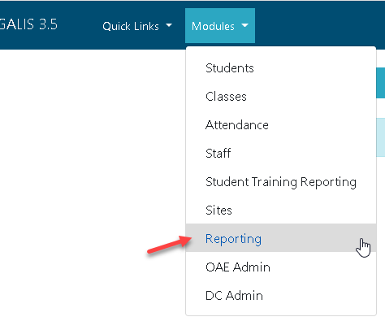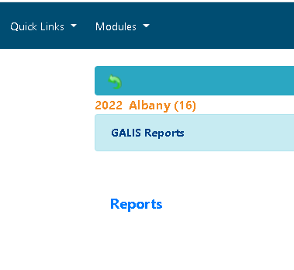
- You will be directed to a new Welcome Page in COGNOS
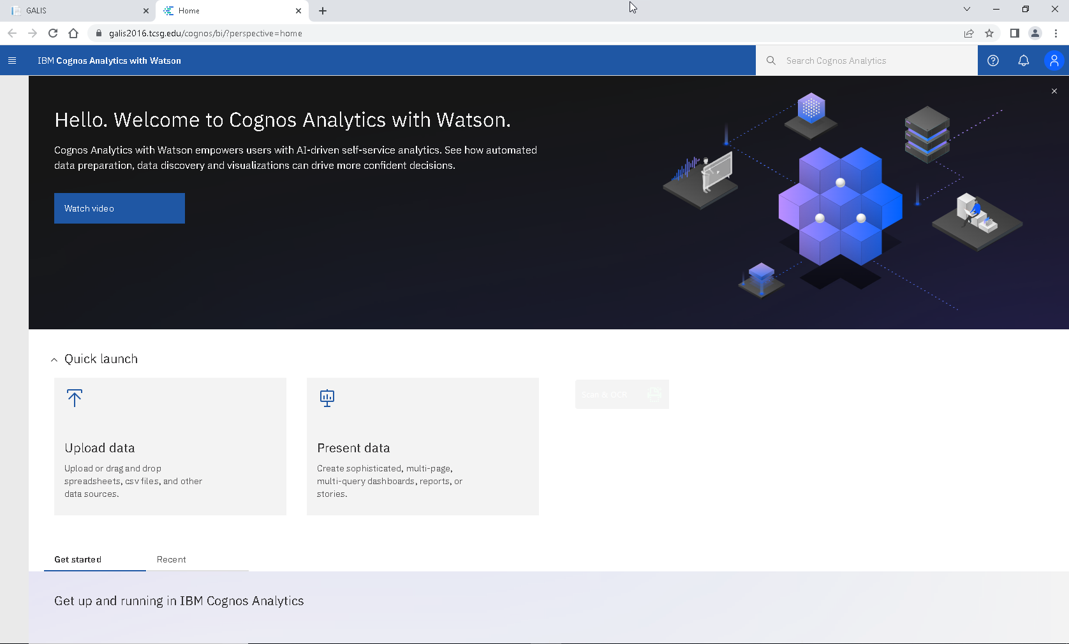
- Open the menu on the top left and select ‘Content’
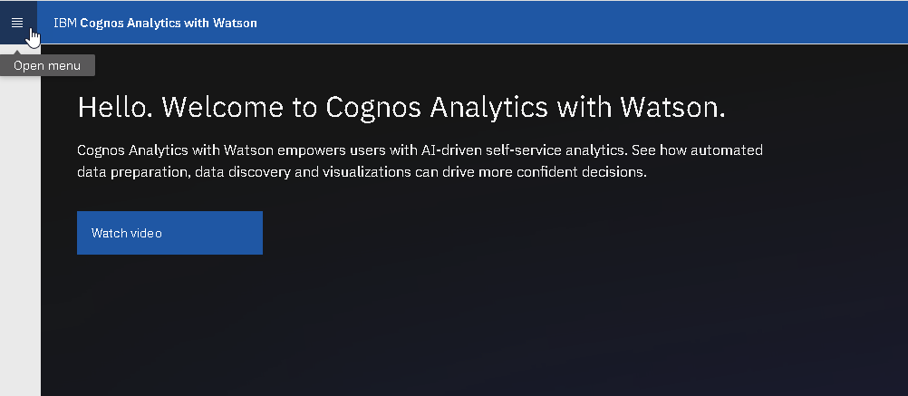

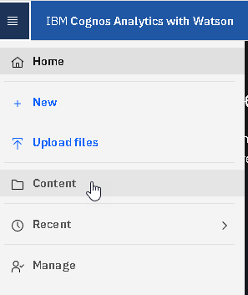
Select Team Content
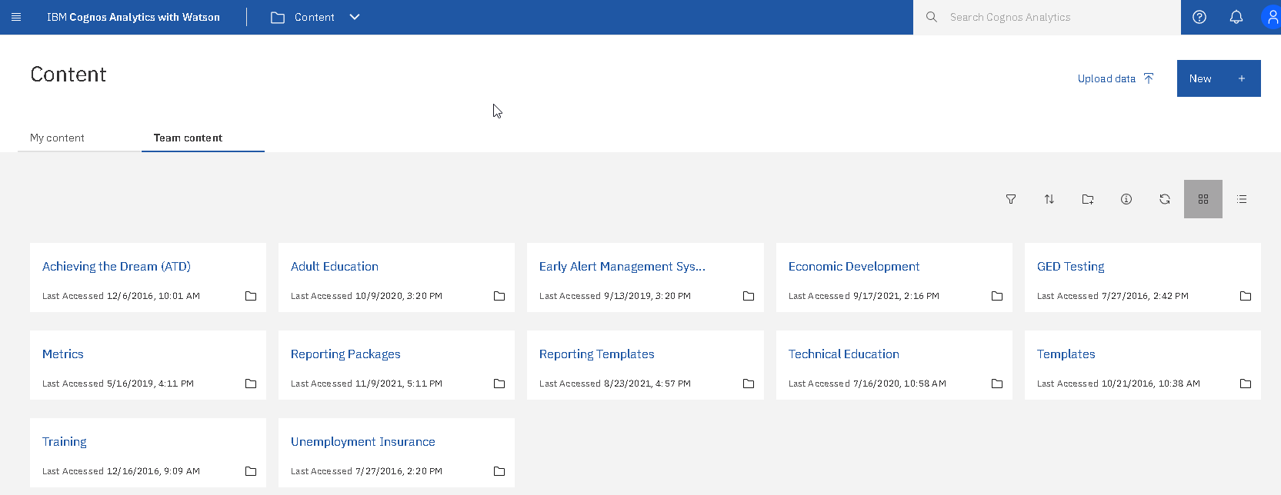

- Select Adult Education
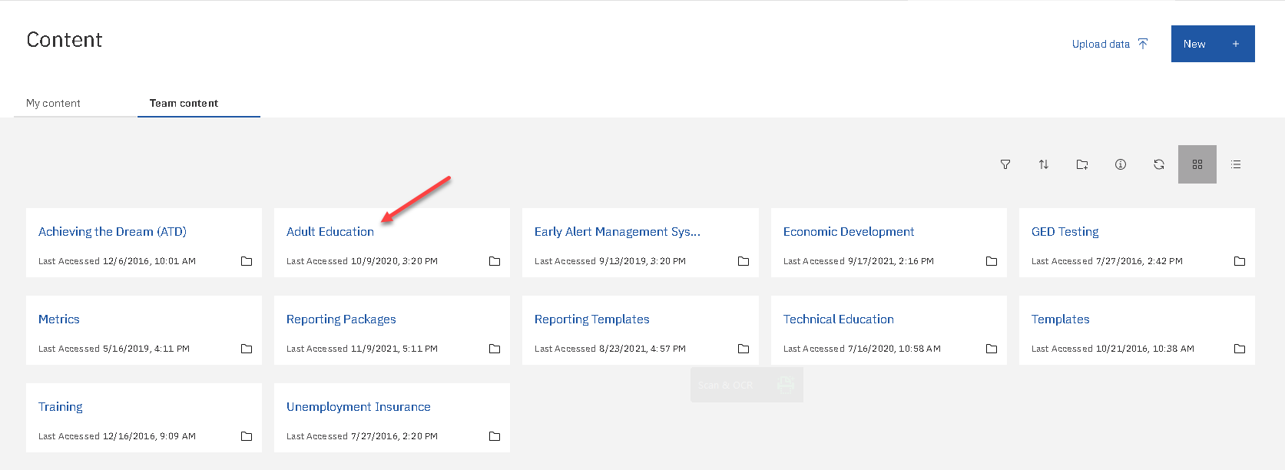

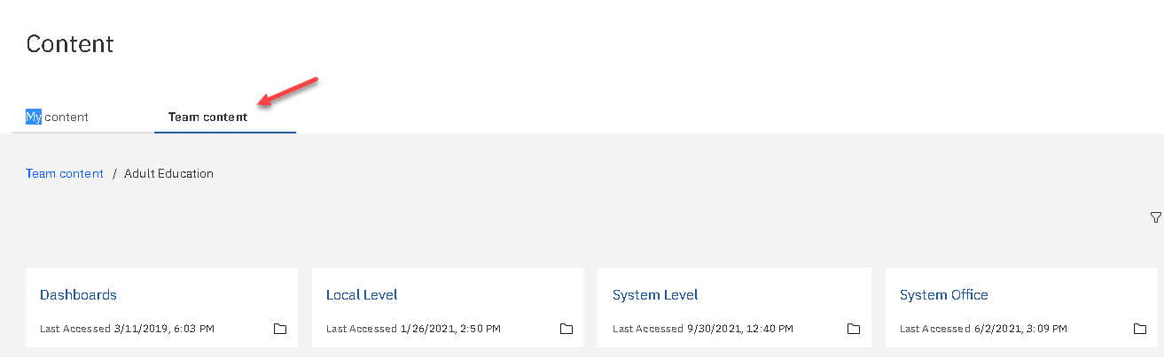
Your access level will determine what options will be available

- Report List Options – Grid/List
COGNOS gives the user the following options:
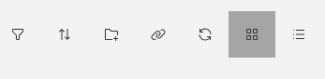
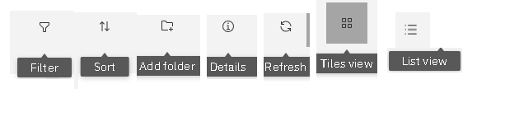
Tile View
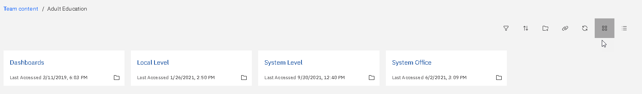

List View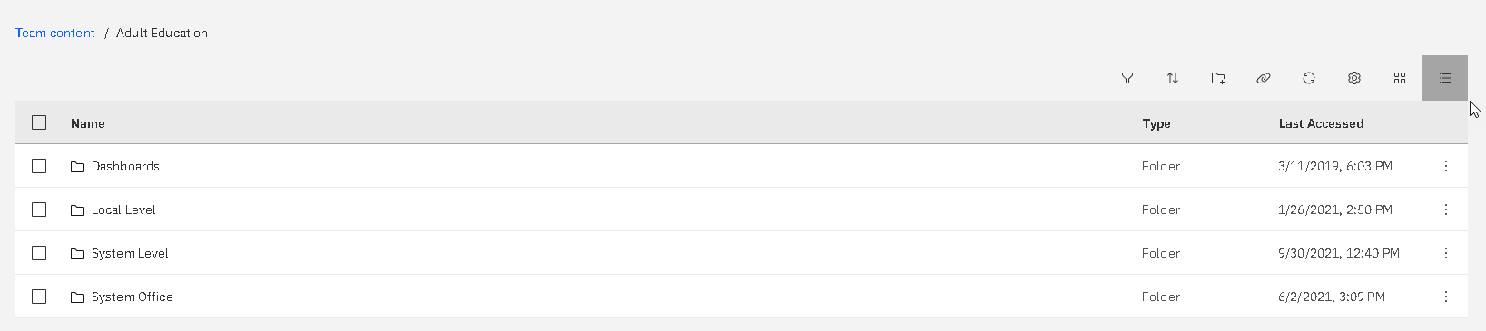

- Report Selection

The system will display the reports in the group selected.

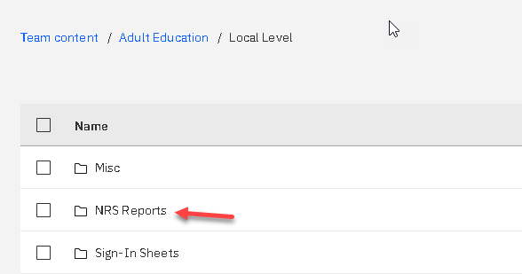

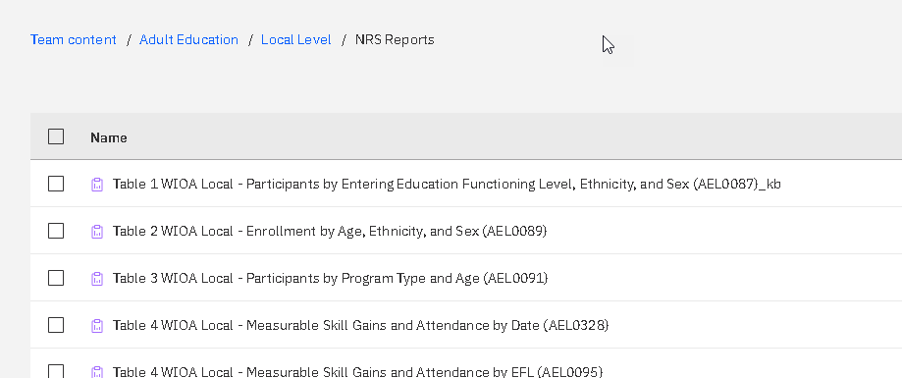
There are no changes in the running of the reports.

- Search Reports
The upgraded COGNOS has the option to search for reports. From the Home Page you can search for reports if you know the Report Name or Report Number. A list of reports can be found in the GALIS Reports User Guide.
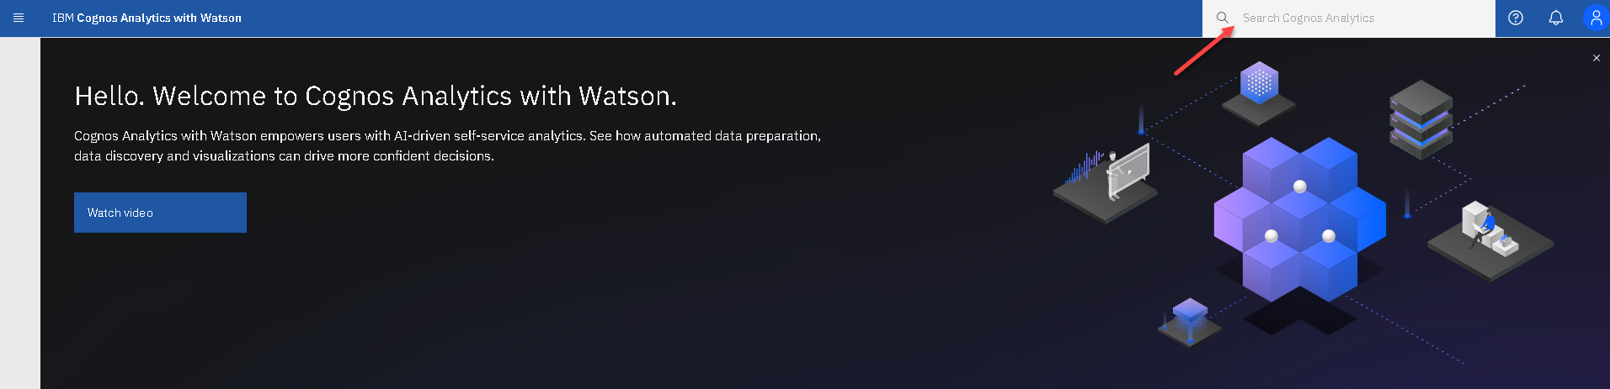
Enter your search criteria and the system will display a suggested list that includes your search criteria.
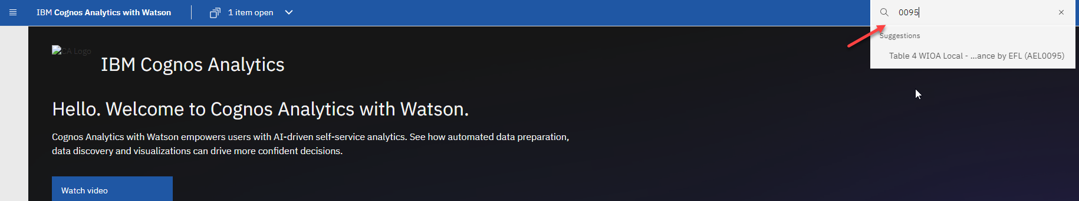
Click on the report you want to run
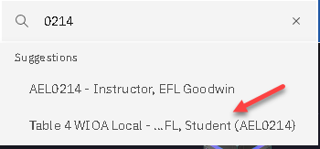
Select the report
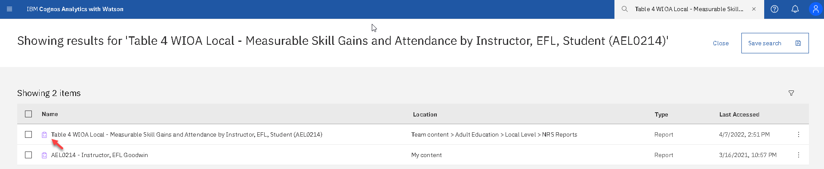
- Run the report
